**NAAN MUDHAVAN**

**PROJECT DOCUMENT**

**COURSE TITLE** : DIGITAL MARKETING

**COLLEGE CODE** : 1105

**COLLEGE NAME** : GOJAN SCHOOL OF BUSINESS AND TECHNOLOGY

**PROJECT TITLE** : BRAND PROMO VIDEO

**PROJECT TEAM ID** : NM2023TMID05717

**TEAM LEADER**

**NM ID** : 94ADAF9DCE94898A90C48DB66511FE88

**NAME** : DILLIBABU D

**TEAM MEMBER 1**

**NM ID** : F3FD49126548E859A5E4125EF70B1104

**NAME** : PRAVEEN KUMAR S

**TEAM MEMBER 2**

**NM ID** : 1001FB625E2BA7F8F0649E5D7BA2BAF0

**NAME** : RAHUL ANAND A

**TEAM MEMBER 3**

**NM ID** : FBA06EE4A1B0828A00F4BB1F904486C5

**NAME** : RAJKUMAR R

**TEAM MEMBER 4**

**NM ID** : 588CE6B9DA0968E946D468F351D5961A

**NAME** : VIJAY R

**BRAND NAME** : KD SOFTWARE SOLUTION

**BRAND MAIL-ID** : kdsysytemservice@gmail.com

**PASSWORD** : 9087853465

**SOCIAL MEDIA LINK** : <https://www.facebook.com/profile.php?id=61551344957315>

**DRIVE LINK** : <https://drive.google.com/drive/u/2/my-drive>

**BRAND NAME :**KD SYSTEM SERVICE

**CATEGORY :**SOFTWARE AND HARDWARE

**TARGET :**ALL SYSTEM USERS

**EMAIL :**kdsystemservice@gmail.com

**HERE ARE THE STEP TO CREATE BRAND PROMO VIDEO IN CANVA**

1. **Creeate account in canva**

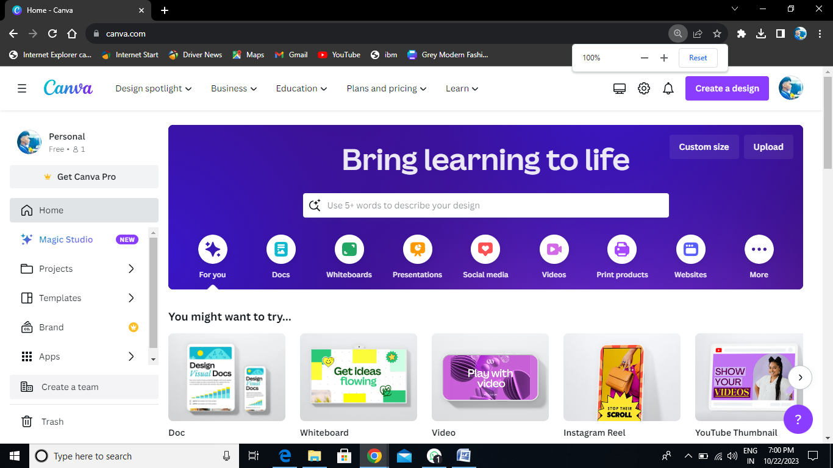

1. **Select video template**

**On the canva Dashboarb click Create a Design and select video (1920*1080 px) and custumize video content**

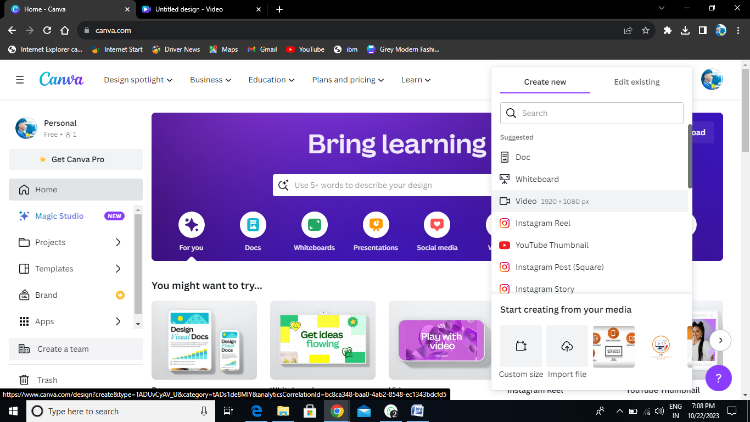

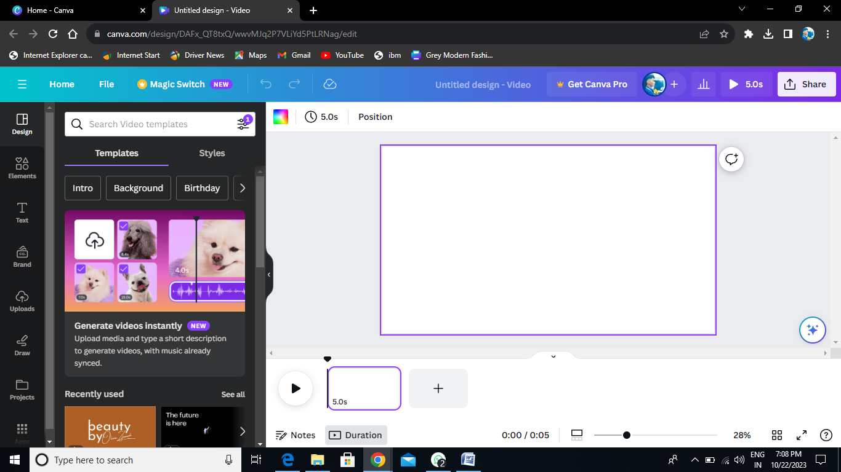

1. **Edit and arrange content**

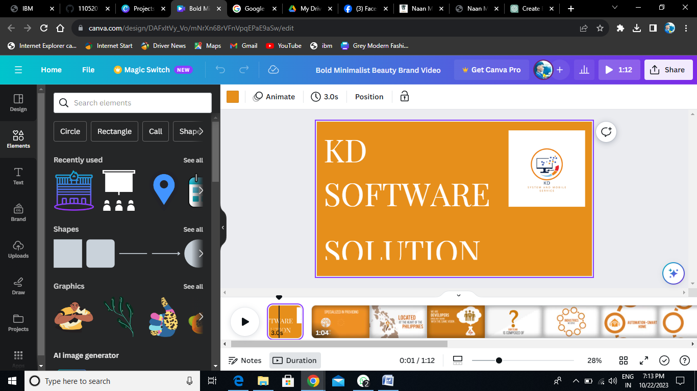

1. **Add music and animation**

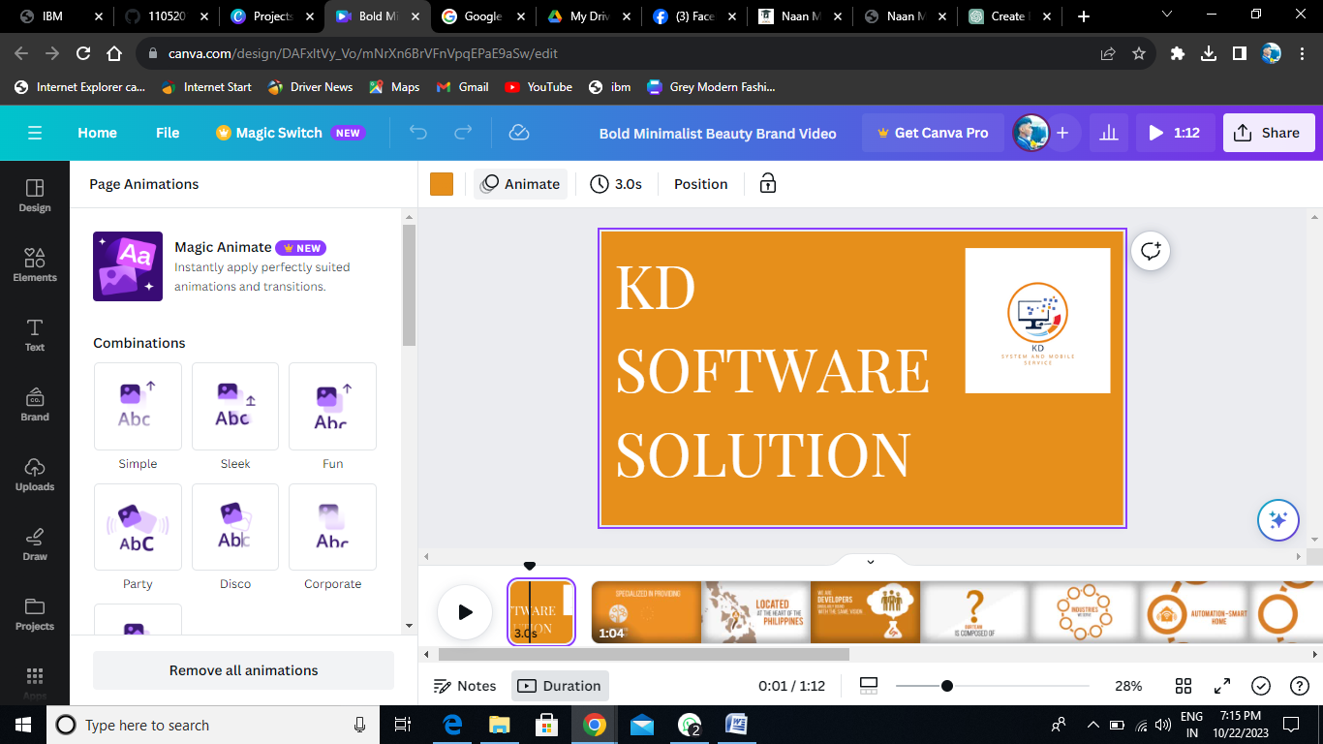

1. **Export video**

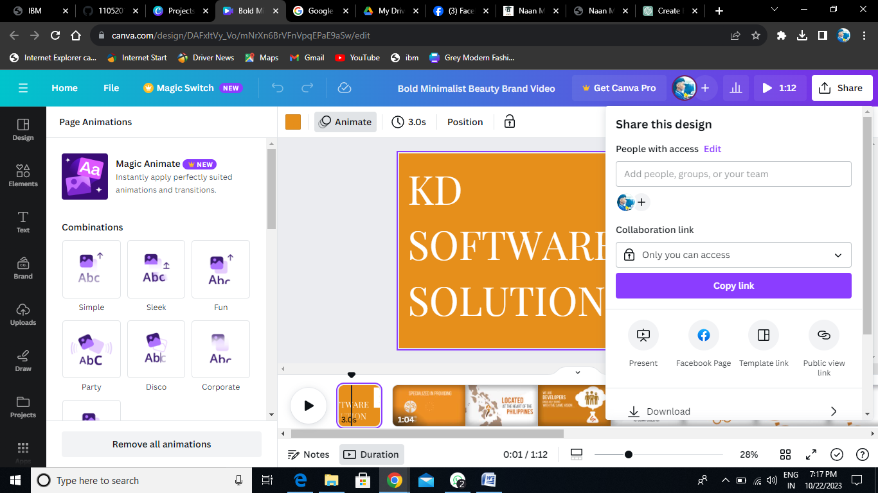

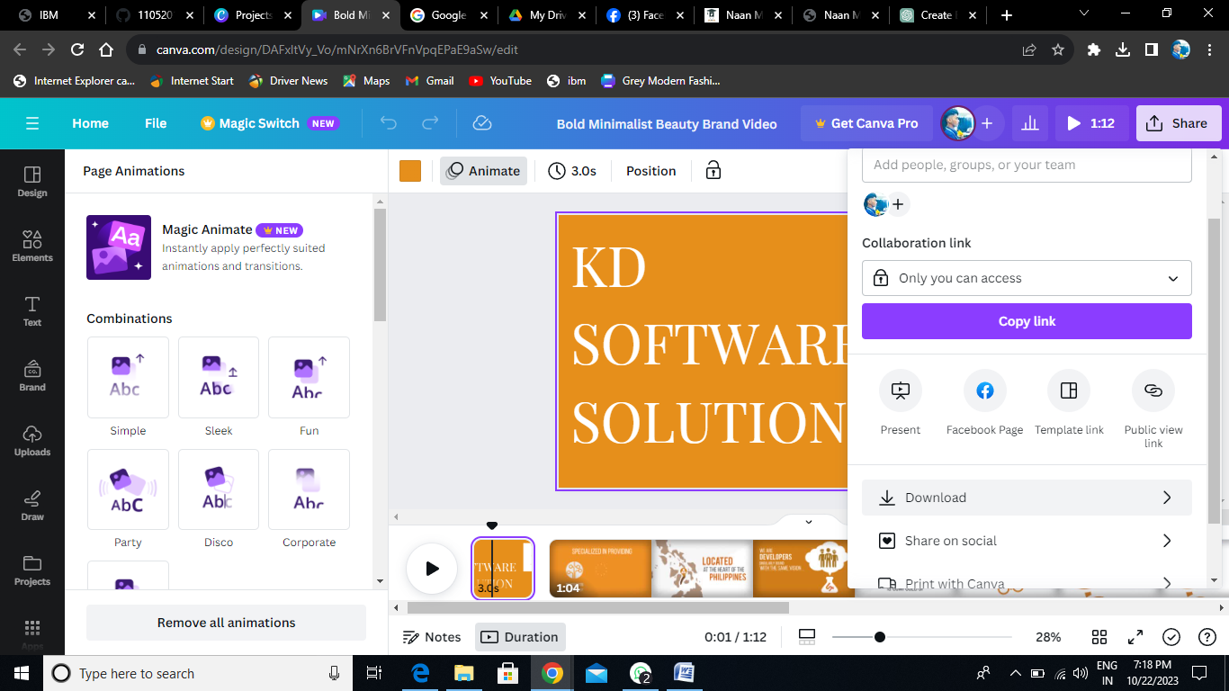

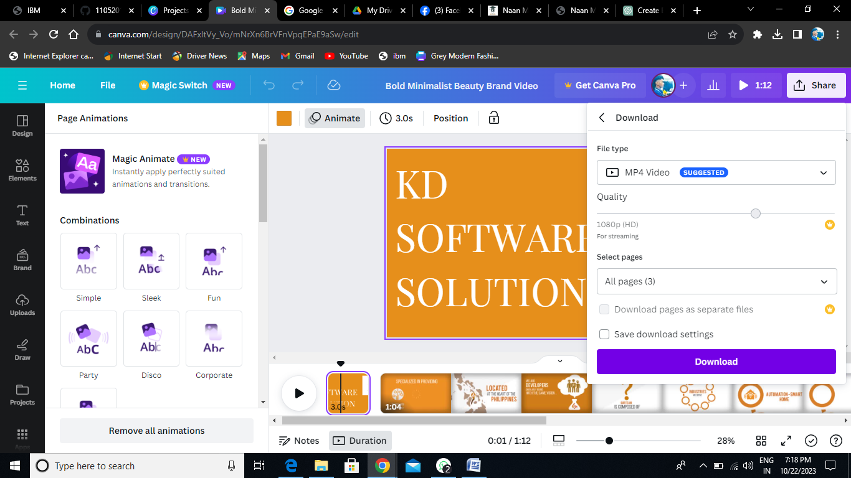

1. **Upload in social media**

[**https://www.facebook.com/61551344957315/videos/3032622420204136**](https://www.facebook.com/61551344957315/videos/3032622420204136)

